Test 3: num*plants = 167 targetsize = (299,299) batchsize = 48 epochs = 100 Model: "sequential" __* Layer (type) Output Shape Param #  
================================================================= inception_resnet*v2 (Model) (None, None, None, 1536) 54336736  
__* global_average*pooling2d (Gl (None, 1536) 0  
__* dense (Dense) (None, 4096) 6295552  
_ dense*1 (Dense) (None, 2048) 8390656  
__* dense*2 (Dense) (None, 1024) 2098176  
__* dense_3 (Dense) (None, 167) 171175  
================================================================= Total params: 71,292,295 Trainable params: 71,231,751 Non-trainable params: 60,544 72/72 [==============================] - 126s 2s/step - loss: 1.1210 - accuracy: 0.7083 test acc: 0.7083333

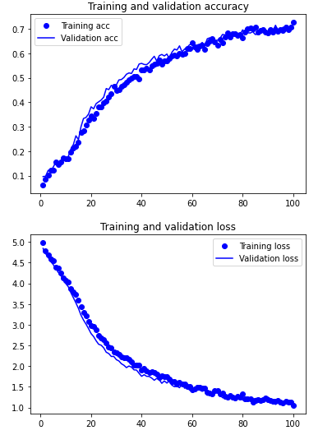

Conclusion: Accuracy slightly increased with larger representation space. Also increased batch size. Going to test a different convolution base.